Final Project: Student Professional

Portfolio Website

Shalitha Dehigaspitiyage
AH2546
Final project report
Basics of Web Development TT00CD79-3008, Kari Niemi
02.12.2025
Information and Communications Technology
Live URL: https://student.labranet.jamk.fi/~ah2546/web_development/final_version/index.html

Contents
1 Project Synopsis 2
1.1 Overview & Design Philosophy 2
1.2 Target Audience 2
1.3 Technical Compatibility 2
2 Features & Implementation 3
2.1 Sticky Navigation Bar 3
2.2 Dynamic "Back to Top" Button 3
2.3 Direct Email Integration: 3
3 Information Architecture 3
4 Design & Wireframes 4
4.1 Desktop Layout 4
4.2 Mobile Layout 5
5. Conclusion & Self-Reflection 5
Appendices 6
Appendix 1. Desktop design layout 6
Appendix 2. Mobile design layout 8

Figures
Figure 1: Website Architecture 4

Project Synopsis

Overview & Design Philosophy
This website serves as the comprehensive final capstone for the Web Development curriculum, designed to function as a professional student portfolio. The site employs a modern, minimalist design language, deliberately prioritizing content structure and legibility over decorative
aesthetics. This "content-first" approach ensures that the user’s focus remains strictly on
professional achievements, skills, and educational background, rather than distracting visual
elements.

Target Audience
The primary user experience (UX) is optimized for personnel managers, HR professionals, and
recruiters. While the interface incorporates fully responsive design principles for mobile
compatibility, the layout is specifically tuned for desktop and laptop environments where
recruiters typically operate.

Technical Compatibility
The codebase ensures cross-browser stability and rendering consistency. It has been rigorously tested on major platforms including:
- Mozilla Firefox
- Google Chrome
- Microsoft Edge

Features & Implementation
To ensure a seamless browsing experience, several Quality of Life (QoL) features were
implemented using vanilla JavaScript and CSS:

Sticky Navigation Bar
Provides users with persistent access to the site architecture without needing to scroll back up.

Dynamic "Back to Top" Button
Facilitates efficient navigation on long-form pages.

Direct Email Integration:
The Contact section features a pre-configured mailto interface. This allows the user to draft their message on the site and instigate their native email client with a single click, ensuring a hassle-free connection process

Information Architecture
The website utilizes a flat hierarchy structure. Global sticky navigation acts as the central hub,
allowing users to jump laterally between any of the four distinct pages (Home, Portfolio, Hobbies, Contact) without retracing their steps.
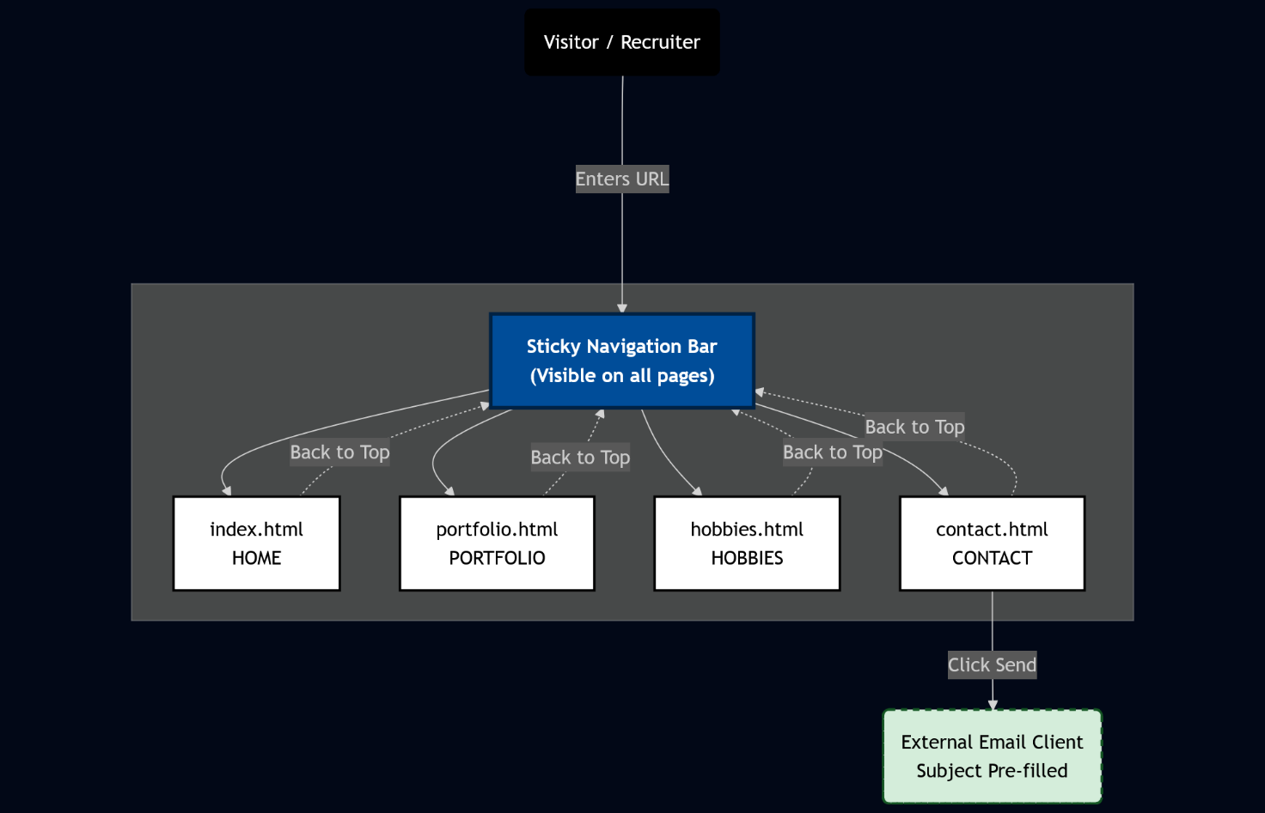
Figure 1: Website Architecture

Design & Wireframes
The design follows a "Content-First" approach. The layout is kept clean with ample whitespace to improve readability for recruiters scanning the document.

Desktop Layout
The desktop view utilizes a grid-based layout to showcase projects side-by-side, maximizing screen real estate.
See Appendix 1

Mobile Layout
The mobile view stacks content vertically using CSS Media Queries, ensuring text remains legible and touch targets (buttons/links) are easily accessible on smaller screens.
See Appendix 2
5. Conclusion & Self-Reflection
This project successfully meets the criteria of a modern, responsive web application. By focusing on a minimalist aesthetic, the site achieves high performance scores and fast load times.
The integration of JavaScript enhances the user experience without over-complicating the
codebase.
Future improvements could include a dark-mode toggle or a backend database for the contact form, but in its current state, the site fulfils its primary goal: presenting professional credentials in a clear, accessible format.

Appendices
Appendix 1. Desktop design layout
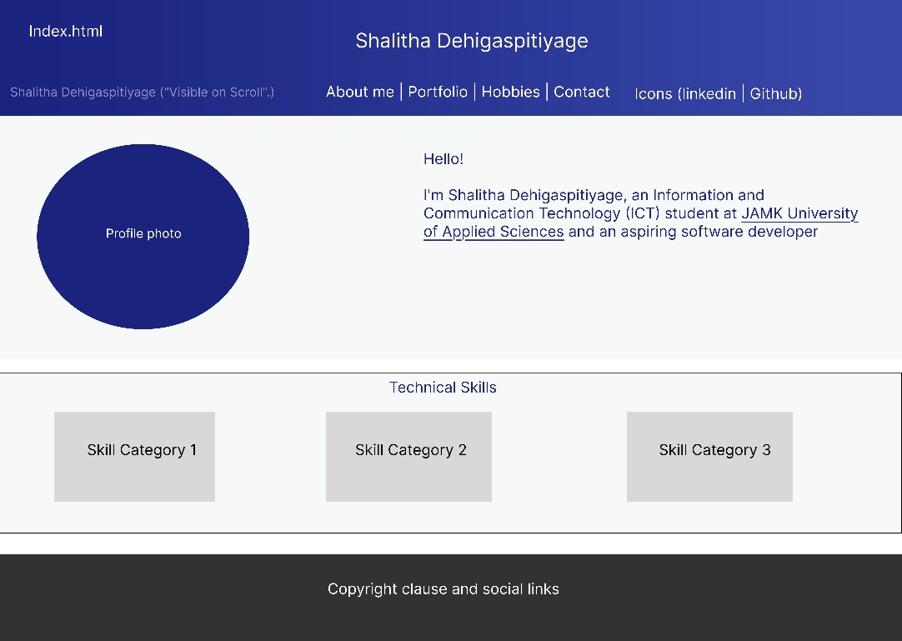
Page 1: Index.html
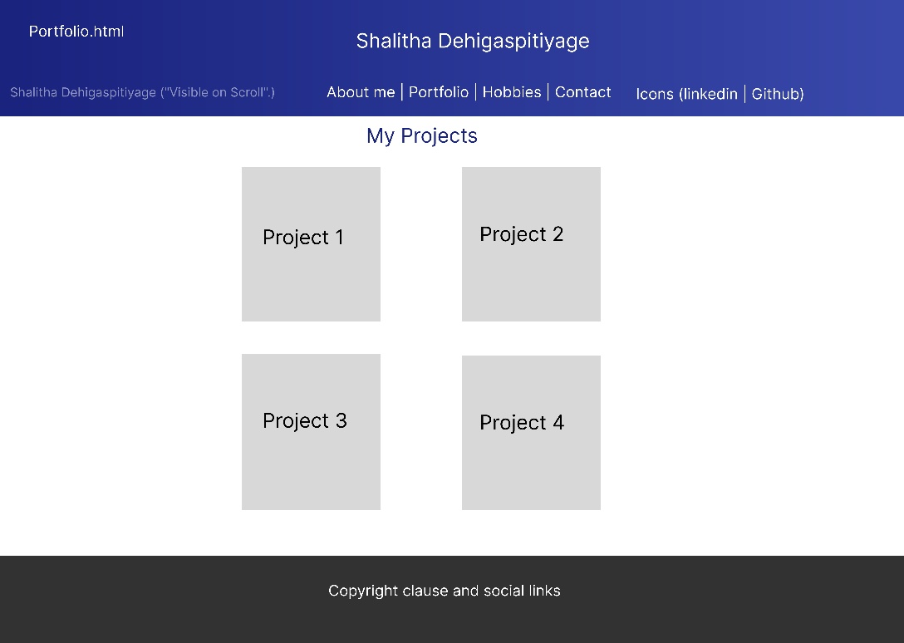
Page 2: Portfolio.html
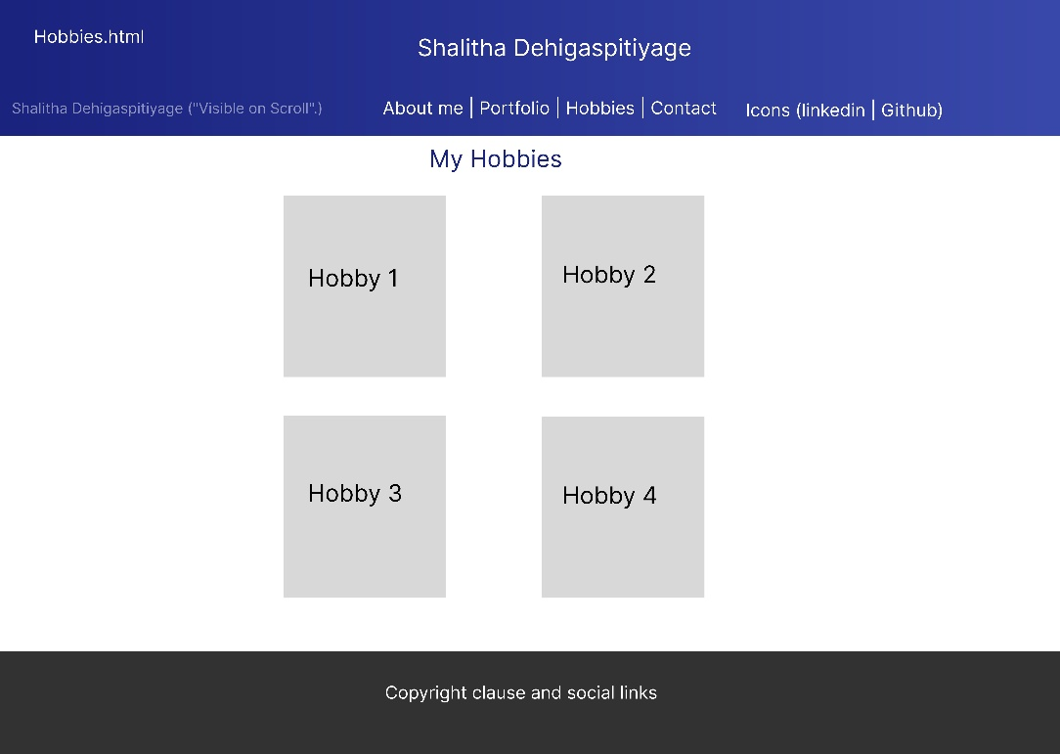
Page 3: Hobbies.html

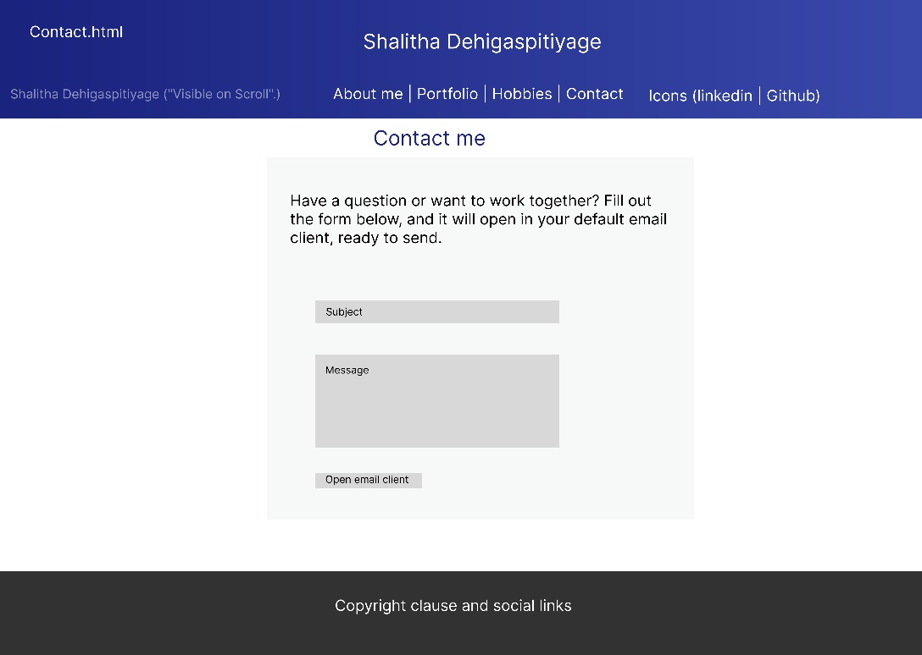
Page 4: Contact.html

Appendix 2. Mobile design layout
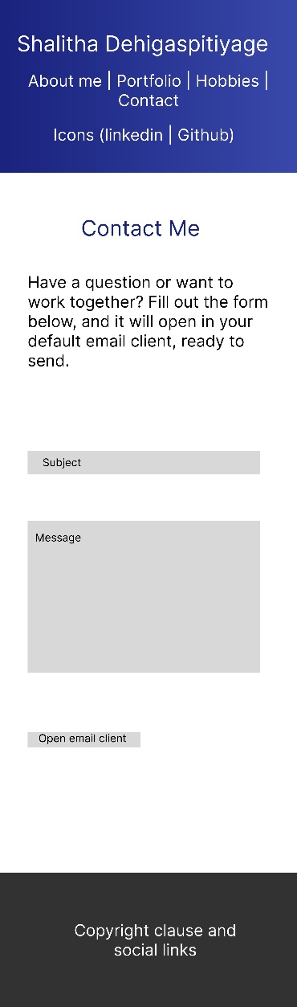
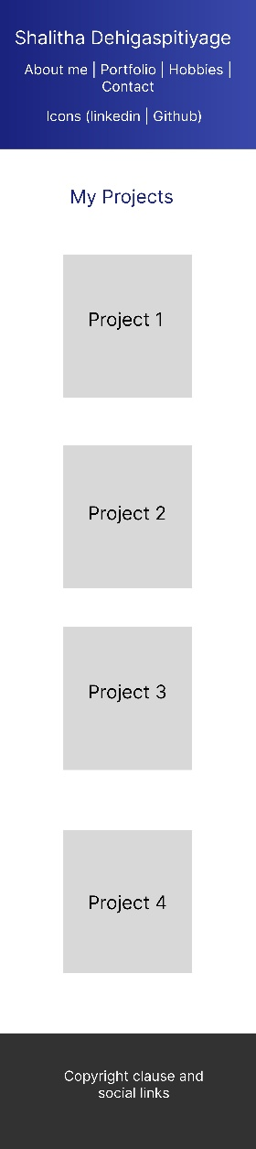
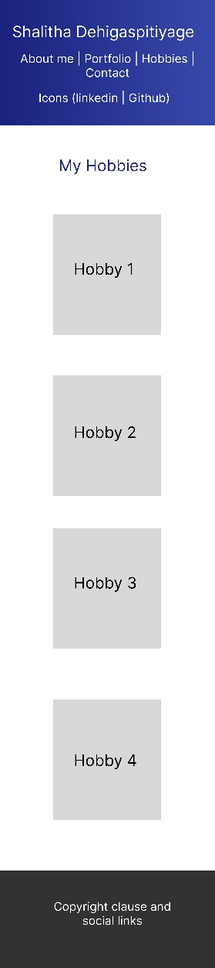
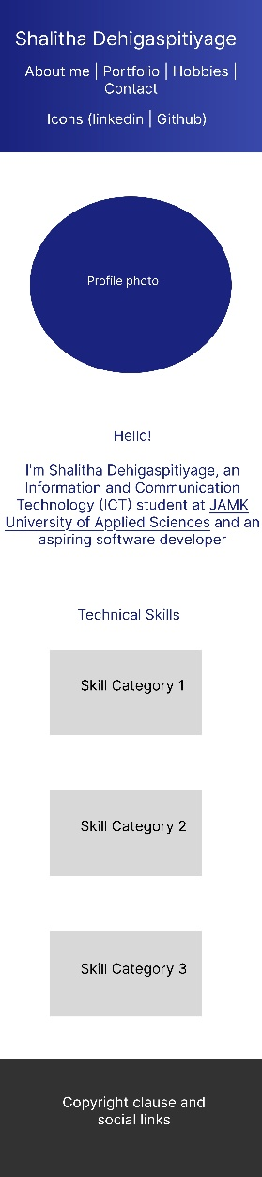
Page 1: Index.html Page 2: Portfolio.html Page 3: Hobbies.html Page 4: Contact.html

